Assignment 3

# Part A: Sequential Learning

Values taken: a=4, b=6

Mean of the data= 0.9

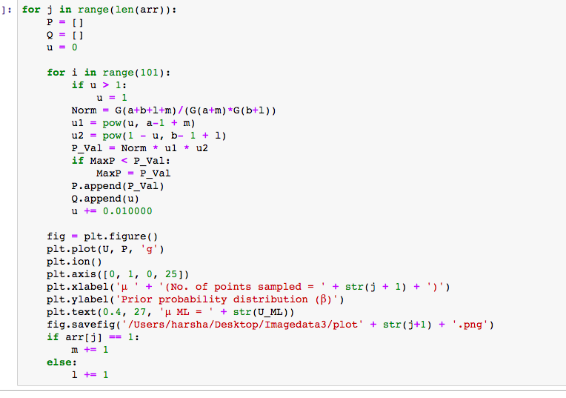

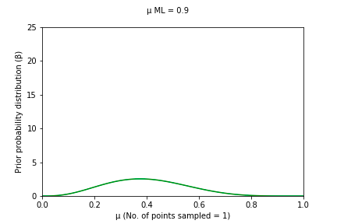

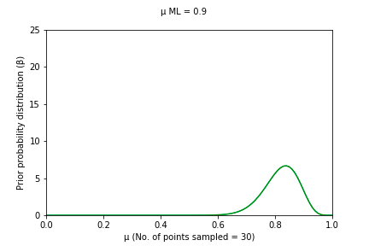

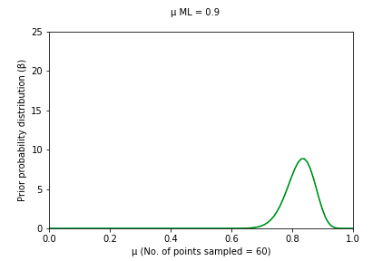

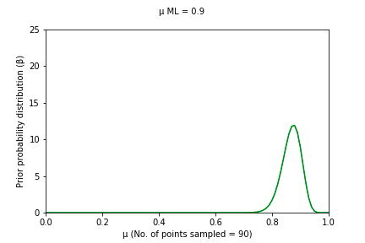

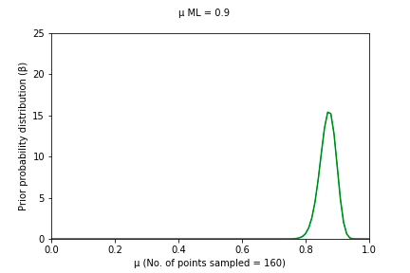

GIF link <https://drive.google.com/drive/u/1/folders/1c_H6LlI1GNsgIfthM1k1KB67XFgbh0i4>

# Part B

**PRIOR FUNCTION**

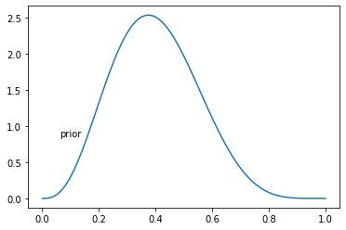

**LIKELIHOOD FUNCTION**

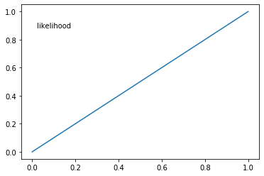

**POSTERIOR FUNCTION**

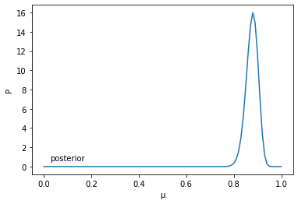

# Part C

# In the sequential learning method, the value of next iteration depends on its previous iteration value. Hence each and every data point impacts individually in a sequential manner and hence a collective outcome is observed . While considering the entire likelihood function at once gives an idea of how the data set as a whole tends to behave.



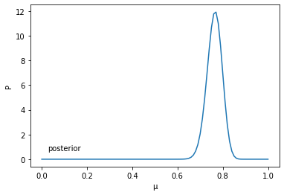

Zip folder of the codes:

# <https://drive.google.com/drive/u/1/folders/1c_H6LlI1GNsgIfthM1k1KB67XFgbh0i4>